BMS Institute of Technology and Management
(An Autonomous Institution Affiliated to VTU, Belagavi)



A Project Report on
“NetShield AI - AI-Driven Early Threat Detection in Enterprise Networks”
Submitted in the partial fulfillment for the requirements of the degree of
BACHELOR OF ENGINEERING IN
ARTIFICIAL INTELLIGENCE AND MACHINE LEARNING
Submitted By
Sambhram Lingaraja 1BY23AI138 Suhas S 1BY23AI154
Tanish V 1BY23AI175
Vishnu Kashyap D 1BY23AI187
Under the guidance of
Balaraju G
Assistant Professor, Department of AI&ML, BMSIT&M


DEPARTMENT OF ARTIFICIAL INTELLIGENCE AND MACHINE LEARNING
BMS INSTITUTE OF TECHNOLOGY & MANAGEMENT
YELAHANKA, BENGALURU - 560064.
2025-2026


BMS Institute of Technology and Management
Yelahanka, Bangalore.

DEPARTMENT OF ARTIFICIAL INTELLIGENCE & MACHINE LEARNING VISION
To emerge as a leading department in AI and ML by preparing skilled, responsible, and eco-friendly professionals who use technology to improve society.

MISSION
- To equip students with in-depth knowledge in Artificial Intelligence and Machine Learning, built upon a robust foundation in Computer Science and Engineering through industry focused curriculum with practical learning.

- To encourage research and innovation through industry partnerships and sustainable technology practices.
- To inspire students toward ethical leadership and entrepreneurship through innovative and collaborative student-led activities.

Program Educational Objectives (PEO’s)
PEO1: Graduates will thrive as IT professionals, applying AI and ML to build creative and lasting solutions.

PEO2: Graduates will pursue further studies, research, and entrepreneurship, keeping up with technological advancements in various fields
PEO3: Graduates will demonstrate ethics, integrity, leadership, teamwork, and a dedication to continuous learning in their careers

Program Specific Outcomes (PSO)

PSO1: Apply foundational knowledge of Computer Science along with AI and ML techniques to design effective, real-world solutions across diverse application domains.
PSO2: Develop AI-driven innovations with a commitment to ethics, social responsibility, and sustainability

VISVESVARAYATECHNOLOGICALUNIVERSITY BELAGAVI
BMS INSTITUTE OF TECHNOLOGY AND MANAGEMENT
YELAHANKA, BENGALURU – 560064


DEPARTMENT OF ARTIFICIAL INTELLIGENCE AND MACHINE LEARNING

CERTIFICATE

This is to certify that the Project work – BAI606 entitled “NetShield AI - AI-Driven Early Threat Detection in Enterprise Networks” is a Bonafide work carried out by Sambhram Lingaraja (1BY23AI138), Suhas S (1BY23AI170), Tanish V (1BY23AI170), Vishnu Kashyap D (1BY23AI187), in partial fulfillment for the award of Bachelor of Engineering Degree in Artificial Intelligence And Machine Learning of the Visvesvaraya Technological University, Belagavi during the year 2025-2026. It is certified that all corrections/suggestions indicated for Internal Assessment have been incorporated in this report. The Major-Project report has been approved as it satisfies the academic requirements in respect
of Major-Project work for B.E. Degree.

Signature of the Guide Signature of the Signature of the HOD
Project-Coordinator

External VIVA-VOCE
Name of the Examiners Signature with Date

1.

2.

DECLARATION

We Sambhram Lingaraja (1BY23AI138), Suhas S (1BY23AI170), Tanish V (1BY23AI175), Vishnu Kashyap D (1BY23AI187) students of Sixth semester B. E, in the Department of Artificial Intelligence And Machine Learning, BMS Institute of Technology and Management, Bengaluru declare that the Mini-Project work entitled “NetShield AI - AI-Driven Early Threat Detection in Enterprise Networks” has been carried out by us and submitted in partial fulfilment of the course requirements for the award of degree in Bachelor of Engineering in Artificial Intelligence And Machine Learning of Visvesvaraya Technological University, Belagavi during the academic year 2025 - 2026. The matter embodied in this report has not been submitted to any other university or institution for the award of any other degree or diploma.

Sambhram Lingaraja (1BY23AI138)

Suhas S (1BY23AI170)
Tanish V (1BY23AI75)
Vishnu Kashyap D(1BY23AI187)

SDG (Sustainable Development Goals) Mapping

SDG 8 – Decent Work and Economic Growth
The automation of surveillance monitoring reduces the burden of continuous manual
observation, improves operational efficiency, and supports productive and technology-driven
work environments.
SDG 9: Industry, Innovation and Infrastructure
Encourages AI innovation for human-centric emotional care. Strengthens digital infrastructure by integrating advanced technologies like real-time audio processing, facial analysis, and intelligent conversational models.
SDG 16: Peace, Justice and Strong Institutions
Because steganography supports confidentiality, data protection, and cybersecurity, which are critical for maintaining justice, security, and trust in institutions

ABSTRACT

The rapid growth of enterprise networks, cloud infrastructure, and connected digital systems has created a critical need for intelligent cybersecurity solutions capable of detecting threats in real time. Traditional cybersecurity systems mainly rely on signature-based detection and predefined rules, which are often ineffective against evolving, unknown, or sophisticated cyber attacks. This project presents NetShield AI – an AI-Driven Early Threat Detection Framework for Enterprise Networks that uses advanced machine learning and deep learning techniques to automatically detect and classify malicious network activities.
The proposed framework integrates network traffic monitoring, feature engineering, anomaly detection, temporal threat classification, and explainable AI to analyze enterprise network behavior. An Autoencoder-based anomaly detection model is used to learn normal traffic patterns and identify suspicious activities through reconstruction error analysis. The detected anomalous traffic is further processed using a Bidirectional Long Short-Term Memory (BiLSTM) model to classify different cyber threats such as DoS/DDoS attacks, brute force attacks, port scanning, malware communication, botnet activity, and data exfiltration attempts. SHAP-based explainable AI is incorporated to provide transparent interpretation of model predictions and identify the key factors contributing to detected threats.
The system also includes real-time alert generation, threat reporting dashboards, and a dynamic feedback loop for continuous model retraining, enabling adaptive learning against evolving cyber attack patterns. By combining intelligent anomaly detection, sequential threat analysis, and explainable AI, the proposed framework aims to improve cybersecurity monitoring, reduce false positives, and strengthen enterprise network defense through proactive AI-driven threat detection.

TABLE OF CONTENTS

Chapter 1:Introduction 1
  - Background 2
  - Literature Survey 2
  - Motivation 4
  - Problem Statement 4
  - Aim and Objective 4
  - Scope 5
  - Challenges 5
Chapter 2: Overview 6
Chapter 3: Requirement Specification 7
  - Mapping of Requirements 7
  - Functional Requirements 7
  - Non-Functional Requirements 8
  - User Requirements 8
  - Domain Requirements 9
  - System Requirements 10
Chapter 4: Detailed Design 11
  - System Architecture 11
  - System Design 12
  - Activity Diagram 14
  - Use Case Diagram 15
  - Class Diagram 17
  - Sequence Diagram 18
  - Data Flow Diagram 18
IV
Chapter 5: Implementation 19
  - Programming Language 19
  - Algorithms 19
  - Proposed Design 20
  - Code 21
Chapter 6: Testing 22
  - Test Objectives 22
  - Testing Phases 22
  - Test Cases 23
  - Performance Evaluation 23
  - Testing Tools Used………………………………………………………………23
Chapter 7: Experimental Results 24
  - Home Page 24
  - Analytics Page 24
  - Log Pags 25
  - Alert Page 25
  - Model Training Page 26
  - User Management…………………………………………………………………26
  - Settings……………………………………………………………………………26
Chapter 8: Conclusion 27
Chapter 9: Future Enhancements 28
References 29

LIST OF FIGURES

Figure 1 System Architecture 11

Figure 2 Activity Diagram 14

Figure 3 Use Case Diagram 15

Figure 4 Class Diagram 17

Figure 5 Sequence Diagram 18

Figure 6 Data Flow Diagram 18

Figure 7 Home Page 24

Figure 8 Analytics 24

Figure 9 Logs 25

Figure 10 Alerts 25

Figure 11 Model Training 26

Figure 12 User Management……………………………………………………………………...26

Figure 13 Settings…………………………………………………………………………………26

CHAPTER 1: INTRODUCTION

With the rapid expansion of enterprise networks, cloud computing platforms, IoT-connected devices, and remote digital infrastructures, cybersecurity has become one of the most critical challenges in modern organizations. Enterprise networks continuously generate massive volumes of traffic, making manual monitoring and traditional security analysis increasingly difficult. Conventional cybersecurity systems primarily depend on signature-based detection methods and predefined rule sets, which are effective only against known attack patterns but often fail to identify unknown, evolving, or sophisticated cyber threats.
Recent advancements in Artificial Intelligence (AI), Machine Learning (ML), and Deep Learning have created new opportunities for building intelligent cybersecurity systems capable of automatically analyzing network behavior and detecting threats at an early stage. Modern cyber attacks such as distributed denial-of-service (DDoS), brute force attacks, malware communication, port scanning, botnet activity, and data exfiltration often exhibit behavioral and temporal patterns that can be learned and recognized using AI-driven techniques.
This project proposes NetShield AI – an AI-Driven Early Threat Detection Framework for Enterprise Networks, designed to intelligently monitor network traffic and detect cyber threats in real time. The framework combines anomaly detection, temporal threat classification, explainable AI, and adaptive feedback mechanisms to improve cybersecurity monitoring. An Autoencoder-based anomaly detection model is used to learn normal network traffic behavior and identify suspicious activities, while a Bidirectional Long Short-Term Memory (BiLSTM) model analyzes sequential traffic patterns to classify specific cyber threats. SHAP-based explainable AI is incorporated to provide transparency in prediction decisions, helping security analysts understand the reasoning behind detected threats.
The proposed system also includes real-time alert generation, reporting dashboards, and a dynamic feedback loop for continuous model retraining, allowing the framework to adapt to emerging attack patterns and improve detection performance over time. By integrating AI-driven behavioral analysis with enterprise network monitoring, NetShield AI aims to provide a scalable, intelligent, and proactive cybersecurity solution for strengthening digital infrastructure protection.

Background
Cybersecurity has become a critical requirement in modern digital infrastructure due to the rapid growth of enterprise networks, cloud computing, IoT devices, and remote work environments. Organizations increasingly depend on interconnected digital systems for communication, data management, and business operations, making them highly vulnerable to sophisticated cyber threats such as DDoS attacks, brute force intrusions, malware communication, botnet activity, and data exfiltration. Traditional security mechanisms like firewalls and signature-based intrusion detection systems are effective against known threats but often fail to detect unknown, evolving, or zero-day attacks. Additionally, the large volume and complexity of enterprise network traffic make manual monitoring inefficient and prone to delayed responses. Recent advancements in Artificial Intelligence, Machine Learning, and Deep Learning have enabled intelligent cybersecurity solutions capable of automatically learning traffic behavior, detecting anomalies, and identifying malicious patterns in real time. The proposed NetShield AI framework leverages these technologies to develop an adaptive and explainable AI-driven early threat detection system that enhances cybersecurity monitoring and strengthens enterprise network security.

Literature Survey

A paper from IEEE Access by V. Prajapati et al. [1] presents an AI-based cybersecurity threat detection framework using LSTM architecture with the CICIDS2017 dataset. The proposed system analyzes enterprise network traffic patterns to detect malicious activities with high accuracy. The authors reported excellent precision and detection performance, but the model faces the risk of overfitting and requires stronger generalization for unseen threats.
A paper from IEEE Transactions on Network and Service Management by P. Bavadiya and S. Gupta [2] proposes a hybrid anomaly detection framework combining Autoencoder, Random Forest, and CNN-LSTM models for cybersecurity analytics. The framework improves anomaly detection capability for enterprise traffic analysis, but unsupervised anomaly detection suffered from limited recall, and the study lacked practical real-time deployment validation.
A paper from IEEE Access by A. R. Alkharabsheh et al. [3] introduces an AI-driven proactive cyber threat prediction framework using Random Forest with SHAP-based explainability. The proposed model improves interpretability in cybersecurity decision-making by highlighting critical threat indicators such as failed login attempts and CPU anomalies. However, the framework was evaluated mainly on synthetic datasets, limiting real-world reliability.
A paper from Journal of Cybersecurity and Digital Transformation by K. Parveen et al. [4] discusses AI-powered cybersecurity monitoring frameworks for enterprise digital infrastructure. The study demonstrates improved detection speed and automation using AI-assisted threat monitoring dashboards, but usability challenges remain for non-technical security administrators.
A paper from Engineering Applications of Artificial Intelligence by R. C. Rekha and Usha J. [5] presents an XGBoost-based intrusion detection framework for zero-trust cybersecurity environments. The system effectively identifies malicious network activities with strong classification performance, but faces limitations when handling heterogeneous enterprise and IoT traffic environments.
A paper from International Journal of Information Security by P. Kumar et al. [6] proposes a deep learning-based cloud cybersecurity threat detection framework using Inception neural architectures. The system demonstrates high scalability and effective attack detection in cloud infrastructures, but experiences latency issues under high-performance enterprise workloads.
A paper from Future Generation Computer Systems by P. Kumar et al. [7] introduces an advanced AI-driven cybersecurity framework integrating Autoencoders, Graph Neural Networks, and LSTM architectures with Explainable AI support. The hybrid architecture improves zero-day threat detection capability, but requires significant computational resources, making real-time enterprise deployment challenging.
A paper from IEEE Access by B. Fetaji and M. Fetaji [8] presents a blockchain-integrated AI cybersecurity early warning framework for detecting advanced persistent threats and zero-day attacks. The framework improves trust and tamper resistance, but blockchain integration introduces computational overhead and impacts throughput performance.
A paper from Smart Cities Journal by P. Simha et al. [9] proposes a multimodal AI threat detection framework combining video, audio, and network intelligence for urban cybersecurity monitoring. The fused architecture reduces false positives significantly, but the complexity of multi-stream data processing limits scalability.
A paper from Computers & Security by R. Sathiaseelan [10] presents a BiLSTM-based behavioral cybersecurity detection framework for ransomware and advanced malware identification. The model effectively detects behavioral attack signatures but depends on continuous retraining to remain effective against evolving ransomware-as-a-service threats.
A paper from Journal of Insider Threat Research by S. M. Parthasarathy [11] discusses AI-driven insider threat detection using Isolation Forest and XGBoost with behavioral profiling. The framework effectively identifies suspicious internal activities and early-stage data exfiltration attempts, but struggles to differentiate accidental actions from intentional malicious behavior.
A paper from Cyber Defense Review by M. Jaworski and B. Pahlevanzadeh [12] proposes a hybrid endpoint defense framework integrating machine learning and behavioral analytics for proactive malware detection. The system achieves strong endpoint threat detection performance, but lightweight deployment across enterprise endpoints remains challenging.

Motivation
The increasing frequency and sophistication of cyber attacks have created a strong need for intelligent and proactive cybersecurity solutions capable of protecting modern enterprise networks. Traditional rule-based and signature-based security systems often struggle to detect unknown or evolving threats, resulting in delayed responses, high false positives, and potential data breaches. With the rapid growth of cloud infrastructure, IoT devices, and large-scale network communication, manual monitoring of network traffic has become impractical and inefficient. This motivated the development of NetShield AI, an AI-driven cybersecurity framework that can automatically analyze network behavior, detect anomalies at an early stage, classify cyber threats accurately, and provide explainable insights for security analysts. The project aims to improve enterprise cybersecurity resilience by combining advanced deep learning techniques with adaptive threat detection and continuous learning capabilities.

Problem Statement
With the rapid growth of enterprise networks, cloud infrastructure, and interconnected digital systems, organizations generate massive volumes of network traffic, making cybersecurity monitoring increasingly complex. Traditional security solutions such as firewalls and signature-based intrusion detection systems primarily rely on predefined rules and known attack signatures, making them ineffective against unknown, evolving, or zero-day cyber threats. Additionally, manual monitoring of large-scale network traffic is inefficient and prone to delayed threat detection. Therefore, there is a need for an intelligent AI-driven cybersecurity framework capable of automatically analyzing network traffic behavior, detecting anomalous activities at an early stage, classifying different types of cyber threats, and providing explainable insights for security analysts. The proposed NetShield AI system aims to address these challenges by developing an adaptive early threat detection framework using deep learning and explainable AI techniques for enterprise network security.

Aim and Objective
Aim:
To design and develop an intelligent AI-driven cybersecurity framework capable of detecting early-stage cyber threats in enterprise networks through anomaly detection, temporal threat classification, explainable AI, and adaptive learning mechanisms.
Objectives:
- To analyze and preprocess enterprise network traffic data for cybersecurity threat analysis.
- To develop an Autoencoder-based anomaly detection model for identifying abnormal network behavior.
- To implement a BiLSTM-based deep learning model for classifying different types of cyber threats based on temporal traffic patterns.
- To integrate SHAP-based explainable AI for interpreting model predictions and improving transparency in threat detection.
- To design a dynamic feedback mechanism for continuous model retraining and adaptation to evolving cyber threats.

Scope
The scope of this project is to develop an intelligent AI-driven cybersecurity framework for early threat detection in enterprise network environments. The system focuses on analyzing network traffic behavior, identifying anomalous activities, and classifying potential cyber threats in real time to strengthen network security monitoring.
The proposed framework integrates advanced deep learning techniques such as Autoencoder-based anomaly detection and BiLSTM-based temporal threat classification, along with SHAP-based explainable AI for transparent decision-making. The system is designed to detect various cyber threats including DDoS attacks, brute force intrusions, port scanning, malware communication, botnet activity, and data exfiltration attempts while generating alerts for security analysts.
The framework can be applied in enterprise networks, cloud infrastructures, educational institutions, and other digitally connected environments that require proactive cybersecurity protection. The project primarily emphasizes intelligent threat detection, adaptive learning through dynamic feedback, explainability, scalability, and practical deployment for modern cybersecurity applications.

Challenges
- Real-Time Network Traffic Processing: Processing large volumes of network traffic in real time while maintaining efficient threat detection performance is computationally challenging.
- Accurate Threat Detection: Differentiating between normal traffic behavior and sophisticated cyber attacks while minimizing false positives requires robust model design and feature engineering.
- Evolving Attack Patterns: Cyber threats continuously evolve, making static detection models less effective over time and requiring adaptive retraining mechanisms.
- Explainability and Trust: Deep learning models often behave as black boxes, making it difficult for security analysts to understand prediction decisions without explainable AI integration.
- Scalability and Deployment: Deploying the framework in enterprise-scale environments requires efficient handling of large traffic volumes, resource optimization, and reliable integration with existing security infrastructure.

CHAPTER 2: Overview

The proposed project, NetShield AI – AI-Driven Early Threat Detection in Enterprise Networks, focuses on developing an intelligent cybersecurity framework capable of detecting and classifying cyber threats in real time by analyzing enterprise network traffic behavior. The system leverages Artificial Intelligence, Deep Learning, and Explainable AI techniques to identify abnormal network activities and improve threat detection beyond traditional rule-based security mechanisms. By combining anomaly detection, sequential behavior analysis, and adaptive learning, the framework aims to provide proactive cybersecurity monitoring for modern digital infrastructures.
The proposed framework consists of multiple interconnected modules that work together to perform network traffic collection, preprocessing, feature extraction, anomaly detection, threat classification, explainability analysis, alert generation, and continuous model improvement. Network traffic data is collected from enterprise infrastructure or benchmark datasets and transformed into structured network flow features. An Autoencoder model learns normal traffic behavior and detects suspicious anomalies, while a BiLSTM model analyzes temporal traffic patterns to classify specific cyber threats such as DDoS attacks, brute force attacks, port scanning, malware communication, botnet activity, and data exfiltration attempts. SHAP-based explainable AI is integrated to provide interpretable threat predictions, helping security analysts understand model decisions.
The framework also includes real-time alerting, reporting dashboards, and a dynamic feedback mechanism for continuous model retraining and adaptation to evolving cyber threats. The proposed system is designed to reduce false positives, improve detection accuracy, and provide scalable deployment for enterprise networks, cloud infrastructures, and other digitally connected environments. Overall, NetShield AI aims to enhance cybersecurity resilience through intelligent, adaptive, and explainable threat detection.

CHAPTER 3: Requirement Specification

Mapping of Requirements
The proposed NetShield AI system integrates multiple AI-driven cybersecurity modules to provide intelligent early threat detection, anomaly analysis, explainable threat classification, and adaptive security monitoring for enterprise networks. Each requirement is mapped to specific modules of the framework to ensure efficient threat detection and system functionality.
- Network Traffic Collection Module → Collects network flow data and traffic logs from enterprise infrastructure or benchmark datasets for cybersecurity analysis.
- Preprocessing & Feature Engineering Module → Cleans raw network traffic data, extracts relevant behavioral features, and prepares structured input for AI models.
- Anomaly Detection Module → Uses an Autoencoder model to learn normal network traffic behavior and identify suspicious or abnormal activities through reconstruction error analysis.
- Threat Classification Module → Uses a BiLSTM deep learning model to analyze sequential network traffic behavior and classify specific cyber threats.
- Explainable AI Module → Integrates SHAP-based explainability to interpret model predictions and identify key features contributing to detected threats.
- Alert & Notification Module → Generates real-time alerts, threat reports, and notifications for detected cyber incidents.
- Monitoring Dashboard Module → Provides visualization of network activity, detected threats, analytics, and system monitoring for security administrators.
- Dynamic Feedback & Retraining Module → Collects validated threat data and continuously retrains the AI models to adapt to evolving cyber attack patterns.
- Database & Storage Module → Stores traffic logs, anomaly records, model outputs, alert history, and system analytics securely for monitoring and future analysis.
These requirements collectively ensure intelligent threat detection, adaptive cybersecurity monitoring, explainable AI decision-making, and scalable deployment for enterprise network protection.

Functional Requirements

• The system should collect network traffic data from enterprise networks, traffic monitoring tools, or benchmark cybersecurity datasets for analysis.
• The system should preprocess network traffic data by cleaning, normalizing, and extracting meaningful behavioral features for AI-based threat detection.
• The system should detect anomalous network activities using an Autoencoder-based anomaly detection model trained on normal traffic behavior.
• The system should classify detected anomalies into specific cyber threat categories such as DDoS attacks, brute force attacks, port scanning, malware communication, botnet activity, and data exfiltration using a BiLSTM model.
• The system should provide explainable AI-based interpretation of threat predictions using SHAP to help security analysts understand the reasoning behind detected threats.
• The system should generate real-time alerts and notifications whenever suspicious or malicious network activity is detected.
• The system should provide a monitoring dashboard for visualizing network activity, detected threats, analytics, and alert history.
• The system should securely store traffic logs, threat records, model outputs, and alert information for future analysis and reporting.
• The system should support continuous model improvement through a dynamic feedback loop that enables retraining using newly validated traffic data.
• The system should allow administrators to monitor system performance, manage configurations, and review cybersecurity events through an interactive interface.

Non-Functional Requirements
• Performance: The system should provide real-time cyber threat detection with minimal processing delay to ensure timely alert generation and rapid response to suspicious activities.
• Accuracy: The framework should maintain high detection accuracy while minimizing false positives and false negatives in identifying cyber threats.
• Scalability: The system should be capable of handling large volumes of enterprise network traffic and support deployment in expanding network environments.
• Reliability: The system should operate continuously and consistently for long-duration network monitoring without significant performance degradation or failure.
• Security: The framework should ensure secure handling, storage, and access control of network traffic logs, threat records, and system data.
• Explainability: The system should provide interpretable AI predictions to help security analysts understand the reasoning behind detected threats and improve trust in the framework.
• Adaptability: The framework should support continuous learning and retraining through a dynamic feedback mechanism to adapt to evolving cyber attack patterns.
• Usability: The system should provide a user-friendly monitoring dashboard and alert interface for easy threat monitoring, analysis, and management by security administrators.

User Requirements
Users expect that:
- The user should be able to monitor enterprise network traffic and cybersecurity events through an interactive dashboard.
- The user should receive real-time alerts and notifications whenever suspicious or malicious network activity is detected.
- The user should be able to view detected threats along with classification details, confidence scores, and explainable insights generated by the AI models.
- The administrator should be able to manage system configurations, alert thresholds, and monitoring settings based on organizational requirements.
- The user should be able to access threat analytics, historical logs, anomaly reports, and cybersecurity event summaries for analysis and decision-making.
- The system should provide a simple, responsive, and user-friendly interface for effective cybersecurity monitoring and management.
- The administrator should be able to review model performance, feedback data, and retraining updates to ensure continuous system improvement.
- The system should allow users to export reports or cybersecurity event logs for documentation and further investigation.

Domain Requirements
• The system must support network traffic analysis and cybersecurity monitoring for detecting suspicious activities in enterprise network environments.
• The framework must use Artificial Intelligence and Deep Learning models such as Autoencoders and BiLSTM networks for anomaly detection and cyber threat classification.
• The system must support network flow data processing and feature extraction to analyze traffic behavior, connection patterns, and communication anomalies.
• The framework must detect various cyber threats such as DDoS attacks, brute force attacks, port scanning, malware communication, botnet activity, and data exfiltration attempts.
• The system must support Explainable AI (XAI) techniques such as SHAP to provide transparent and interpretable threat predictions for cybersecurity analysts.
• The application must support real-time threat detection and alert generation for proactive cybersecurity monitoring.
• The framework must support continuous learning and adaptive retraining mechanisms to improve detection performance against evolving cyber threats.
• The system should integrate with enterprise security infrastructure such as traffic monitoring tools, log management systems, and network monitoring environments.
• The framework must ensure secure storage and management of network logs, threat records, and system analytics for future analysis and reporting.
• The system should support deployment in enterprise networks, cloud infrastructures, educational institutions, and other digitally connected environments requiring proactive cybersecurity protection.

System Requirements
    - Hardware Requirements
• Processor: Intel Core i5 / AMD Ryzen 5 or higher
• RAM: Minimum 8 GB RAM (16 GB recommended for smooth model training and real-time monitoring)
• Storage: Minimum 256 GB SSD or 500 GB HDD for datasets, logs, and model storage
• Graphics Processing Unit (GPU): NVIDIA GPU with CUDA support (recommended for deep learning model training and faster inference)
• Display: Monitor with minimum 1366 × 768 resolution
• Network Connectivity: Stable internet or enterprise network connectivity for traffic monitoring and alert communication
• Power Supply: Reliable uninterrupted power supply for continuous system monitoring
• Input Devices: Keyboard and Mouse for administration and system management

    - Software Requirements
• Operating System: Windows 10/11, Ubuntu Linux, or other Linux distributions
• Programming Language: Python 3.10 or above
• AI/ML Frameworks: TensorFlow / PyTorch, Scikit-learn
• Data Processing Libraries: Pandas, NumPy, Scapy, Joblib
• Explainable AI Library: SHAP
• Visualization Libraries: Matplotlib, Seaborn, Plotly
• Backend Framework: FastAPI / Flask
• Frontend Technologies: React.js, TailwindCSS (for monitoring dashboard)
• Database: PostgreSQL / MySQL / MongoDB
• Development Tools: VS Code / PyCharm / Jupyter Notebook
• API Testing Tools: Postman / Swagger UI
• Version Control: Git and GitHub
• Containerization (Optional): Docker
• Network Monitoring Tools (Optional for real-time deployment): Wireshark, Zeek, Suricata
• Deployment Environment: Local server / Cloud server / Security Operations Center (SOC) monitoring node

CHAPTER 4: Detailed Design

System Architecture

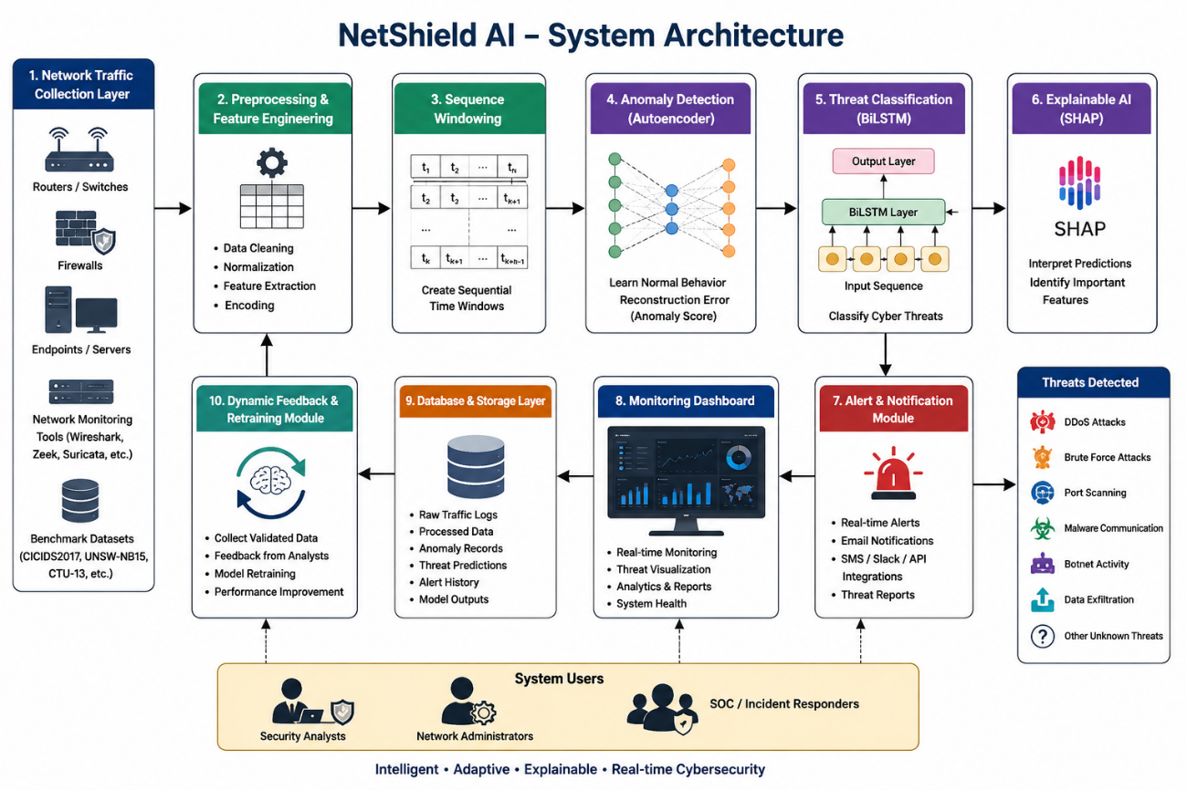
Figure 1 System Architecture
The proposed NetShield AI system architecture is designed as an intelligent AI-powered cybersecurity framework for early threat detection in enterprise networks. The architecture consists of multiple interconnected modules that work together to perform network traffic collection, preprocessing, anomaly detection, threat classification, explainability analysis, alert generation, and continuous model improvement.
- Network Traffic Collection Layer
The system collects network traffic data from enterprise infrastructure such as routers, firewalls, endpoints, network monitoring tools, or benchmark cybersecurity datasets. This layer acts as the primary data source for threat analysis.
- Preprocessing & Feature Engineering Module
The collected traffic data is cleaned, normalized, and transformed into structured network flow features such as packet rate, session duration, bytes transferred, connection frequency, protocol usage, and failed login attempts. These features are prepared for AI-based analysis.
- Sequence Windowing Module
Since the system uses temporal deep learning models, network traffic data is arranged into sequential time windows to capture behavioral patterns over time for effective threat classification.
- Anomaly Detection Module
An Autoencoder-based deep learning model is used to learn normal network traffic behavior. Traffic that significantly deviates from learned normal patterns is identified as anomalous based on reconstruction error analysis.
- Threat Classification Module
Suspicious traffic detected by the anomaly detection layer is passed to a BiLSTM-based classification model, which analyzes sequential traffic behavior and classifies specific cyber threats such as DDoS attacks, brute force attacks, port scanning, malware communication, botnet activity, and data exfiltration attempts.
- Explainable AI Module
SHAP-based explainable AI is integrated to provide transparent interpretation of model predictions by identifying the most influential features contributing to threat detection decisions.
- Alert & Notification Module
When cyber threats are detected, the system generates real-time alerts through dashboards, notifications, and reporting mechanisms to assist security analysts in rapid response and decision-making.
- Database & Storage Layer
The system securely stores network logs, anomaly records, threat history, analytics data, and model outputs for future monitoring, analysis, and reporting.
- Dynamic Feedback & Retraining Module
A continuous feedback mechanism collects validated threat data and retrains the Autoencoder and BiLSTM models periodically, enabling the system to adapt to evolving cyber threats and improve detection accuracy over time.
- Monitoring Dashboard
The frontend dashboard provides visualization of network activity, detected threats, explainable insights, analytics, and system monitoring for administrators and security teams.
The proposed architecture ensures intelligent, adaptive, explainable, and scalable cybersecurity monitoring suitable for enterprise network environments.

System Design
The proposed NetShield AI system is designed as a modular AI-driven cybersecurity framework for intelligent early threat detection in enterprise networks. The system architecture consists of interconnected modules responsible for data collection, preprocessing, anomaly detection, threat classification, explainability, alert generation, storage, and adaptive model improvement. Each module performs a specific role to ensure efficient cybersecurity monitoring and real-time threat detection.

4.2.1 Input Design
The input module collects network traffic data from enterprise infrastructure such as routers, firewalls, endpoints, network monitoring tools, or benchmark cybersecurity datasets like CICIDS2017 and UNSW-NB15. The collected data includes network flow information such as source and destination IP addresses, ports, protocols, packet counts, bytes transferred, and session durations.

4.2.2 Preprocessing & Feature Engineering Design

The preprocessing module cleans and transforms raw network traffic data into structured numerical features suitable for machine learning analysis. This includes handling missing values, normalizing traffic parameters, encoding categorical fields, and extracting behavioral features such as packet rate, connection frequency, session duration, failed login attempts, and protocol usage patterns.

4.2.3 Sequence Windowing Design
Since the system uses a BiLSTM model for temporal threat analysis, traffic data is arranged into sequential time windows. This allows the model to capture evolving traffic behavior over time and detect attack patterns that occur as sequences rather than isolated events.

4.2.4 Anomaly Detection Design
The anomaly detection module uses an Autoencoder neural network to learn normal enterprise network traffic behavior. During monitoring, incoming traffic is reconstructed by the model, and abnormal traffic is identified based on high reconstruction error, indicating deviation from learned normal patterns.

4.2.5 Threat Classification Design
The suspicious traffic identified by the anomaly detection module is passed to the BiLSTM-based threat classification module. This module analyzes sequential network traffic behavior and classifies threats such as DDoS attacks, brute force attacks, port scanning, malware communication, botnet activity, and data exfiltration attempts.

4.2.6 Explainable AI Design
The explainability module integrates SHAP (SHapley Additive Explanations) to provide transparent interpretation of AI model predictions. It identifies the most influential traffic features contributing to detected threats, helping analysts understand the reasoning behind model decisions.

4.2.7 Alert System Design
When a cyber threat is detected, the alert module generates real-time notifications through dashboard alerts, email, API-based integrations, or messaging systems. This ensures rapid incident awareness and supports timely response actions.

4.2.8 Database Design
The storage layer maintains structured records of network traffic logs, anomaly detections, classified threats, model outputs, alert history, and analytics data. Databases such as PostgreSQL or MongoDB can be used for secure storage and efficient retrieval.

4.2.9 Monitoring Dashboard Design
The frontend dashboard provides live monitoring of network traffic behavior, detected threats, alert visualization, explainable AI insights, and performance analytics. This interface allows security analysts and administrators to monitor system activity effectively.

4.2.10 Dynamic Feedback & Retraining Design
The feedback module collects validated threat detections and analyst responses to continuously retrain the Autoencoder and BiLSTM models. This adaptive mechanism enables the framework to improve detection accuracy and remain effective against evolving cyber threats.

Activity Diagram

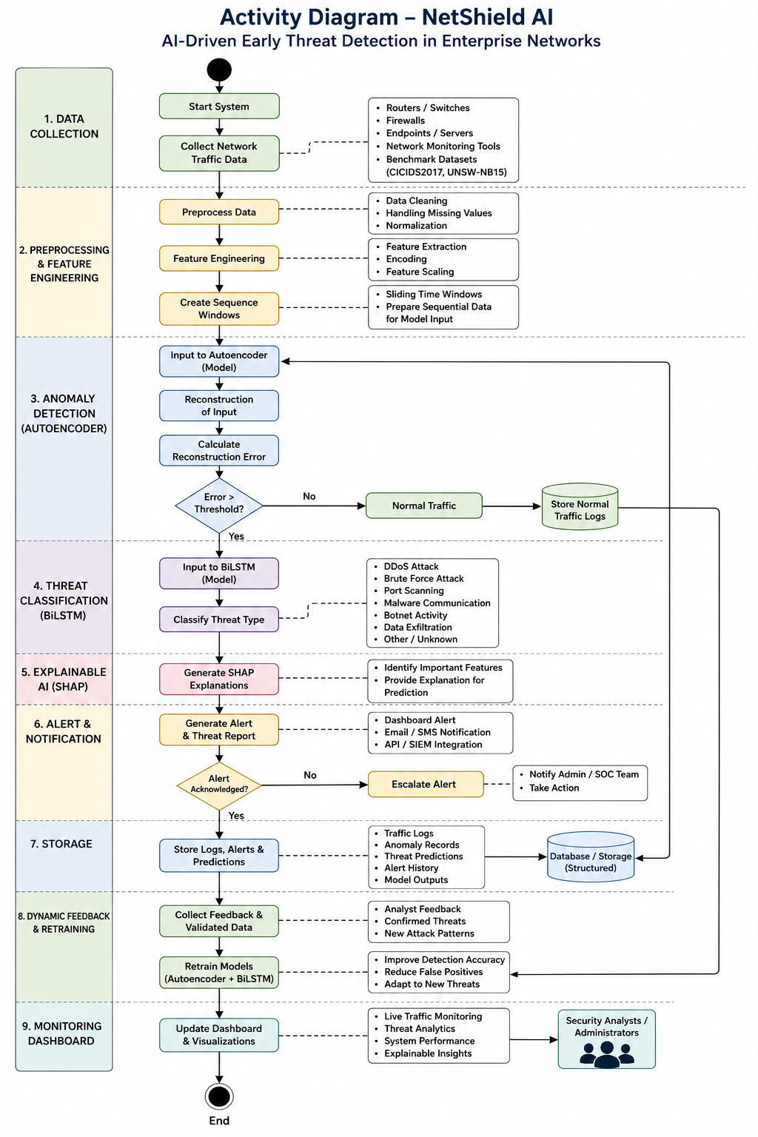
Figure 2 Activity Diagram

Use Case Diagram
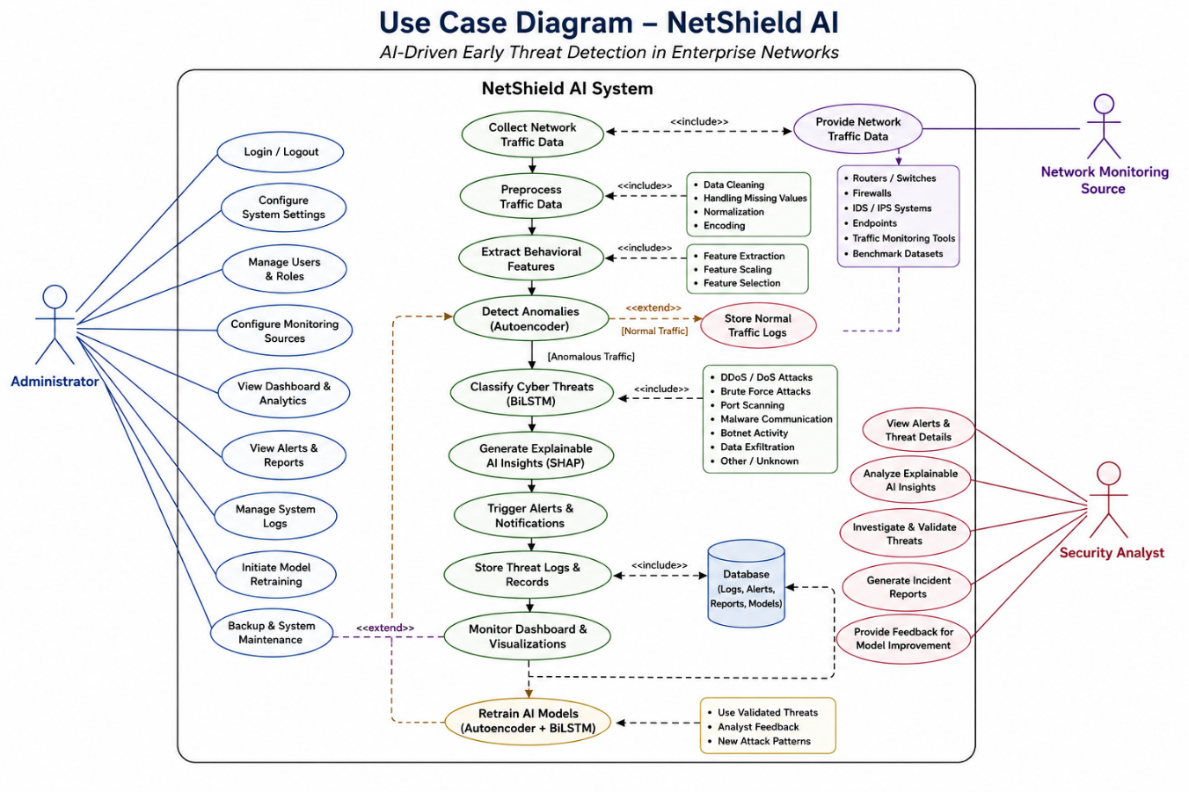
Figure 3 Use Case Diagram
The Use Case Diagram represents the functional interactions between the users and the proposed NetShield AI cybersecurity threat detection framework. It illustrates how different actors interact with the system to perform network monitoring, threat detection, alert management, model supervision, and administrative control. The use case model provides a high-level representation of system functionality and user interactions.
Actors in the System
1. Administrator
The Administrator is responsible for managing the complete cybersecurity monitoring framework. The administrator can:
- Login and logout from the system
- Configure network monitoring sources and system parameters
- Manage user roles and access permissions
- Monitor live network traffic dashboards
- View detected threats and analytics reports
- Configure alert thresholds and notification settings
- Review anomaly detection and classification outputs
- Manage database logs and stored threat records
- Initiate model retraining and feedback validation
- Perform backup, maintenance, and system updates

2. Security Analyst
The Security Analyst is responsible for monitoring detected cyber threats and responding to suspicious activities. The analyst can:
- Monitor live cybersecurity dashboard
- View anomaly alerts and classified threats
- Analyze SHAP-based explainable AI insights
- Investigate suspicious network activities
- Validate or reject detected threats
- Review historical logs and threat analytics
- Generate incident reports
- Provide feedback for model retraining

3. Network Monitoring Source
The Network Monitoring Source acts as the system input provider. It includes enterprise routers, firewalls, IDS/IPS systems, endpoints, traffic monitoring tools, or benchmark datasets. It provides:
- Network traffic flow data
- Connection logs
- IP addresses and protocol information
- Session metadata
- Network behavior statistics

Major System Use Cases
Collect Network Traffic Data
The system captures network flow data from enterprise infrastructure or benchmark cybersecurity datasets for threat analysis.
Preprocess Traffic Data
Collected traffic data is cleaned, normalized, encoded, and transformed into structured features suitable for AI processing.
Extract Behavioral Features
The system extracts cybersecurity-relevant traffic features such as:
- Packet rate
- Session duration
- Bytes transferred
- Connection frequency
- Failed login attempts
- Protocol behavior patterns
Detect Anomalies
The Autoencoder model analyzes network traffic behavior and identifies abnormal activities based on reconstruction error.
Classify Cyber Threats
The BiLSTM model processes suspicious traffic sequences and classifies attack types such as:
- DoS / DDoS attacks
- Brute force attacks
- Port scanning
- Malware communication
- Botnet activity
- Data exfiltration
Generate Explainable AI Insights
The SHAP module explains why a threat was detected by identifying important traffic features contributing to the prediction.
Trigger Alerts
When malicious activity is detected, the system generates real-time alerts via dashboards, notifications, or integrated communication channels.
Store Threat Logs
Detected threats, anomaly records, alert history, and monitoring analytics are securely stored in the database for future analysis.
Monitor Dashboard
The dashboard provides live monitoring of network activity, detected threats, model performance, analytics, and alert history.
Retrain AI Models
Validated threat data and analyst feedback are used to retrain the Autoencoder and BiLSTM models through the adaptive feedback mechanism.

Overall, the Use Case Diagram provides a clear representation of how administrators, security analysts, and network monitoring sources interact with the NetShield AI framework to achieve intelligent, adaptive, and explainable cybersecurity monitoring.

Class Diagram

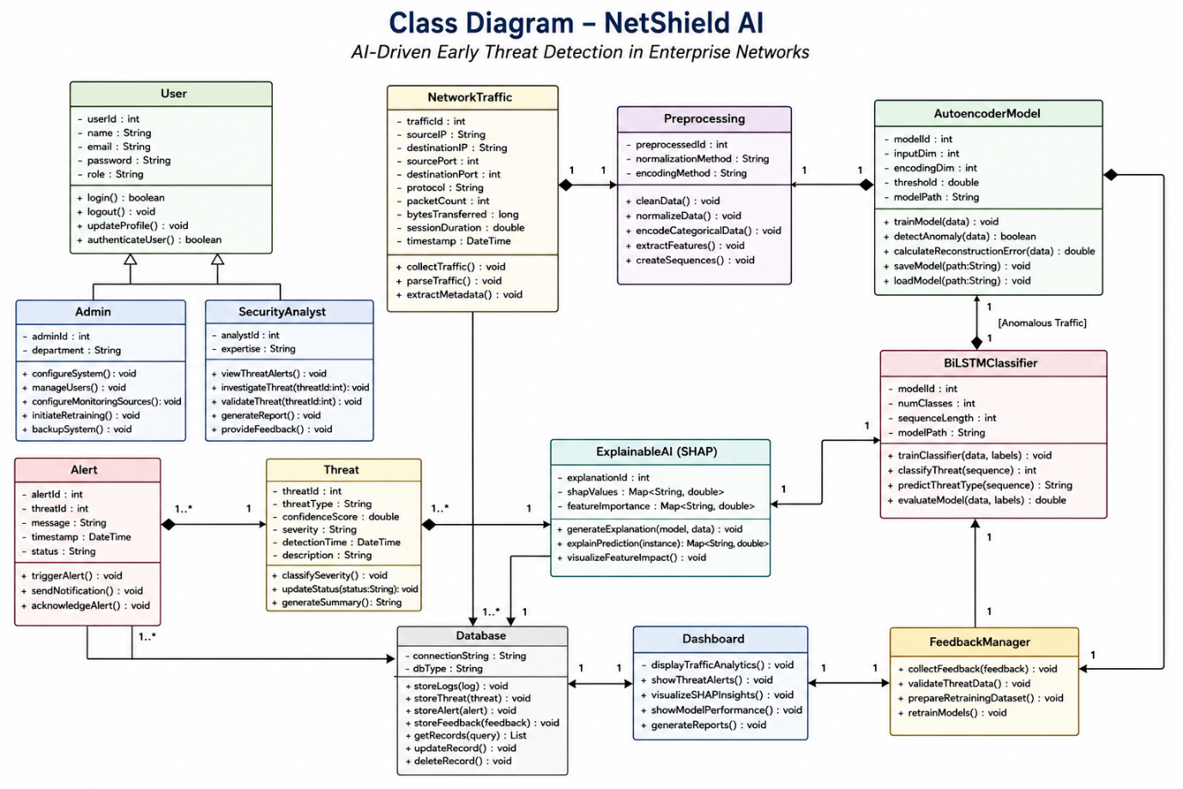
Figure 4 Class Diagram
The Class Diagram represents the structural design of the proposed NetShield AI cybersecurity threat detection framework. It illustrates the major classes, their attributes, methods, and relationships involved in network traffic monitoring, anomaly detection, cyber threat classification, explainable AI analysis, alert generation, data storage, and adaptive model management. The class diagram provides a blueprint of the internal architecture and object-oriented structure of the system.
Major Classes in the System
1. User Class
The User class manages all system users such as administrators and security analysts. It handles authentication, authorization, and access control.
Attributes:
- User ID
- Name
- Email
- Password
- Role
Methods:
- login()
- logout()
- updateProfile()
- authenticateUser()
2. Admin Class
The Admin class inherits from the User class and manages overall system administration.
Methods:
- configureSystem()
- manageUsers()
- configureMonitoringSources()
- initiateRetraining()
- backupSystem()
3. Security Analyst Class
The Security Analyst class is responsible for monitoring detected threats and validating incidents.
Methods:
- viewThreatAlerts()
- investigateThreat()
- validateThreat()
- generateReport()
- provideFeedback()
4. NetworkTraffic Class
This class represents collected network traffic data from enterprise sources.
Attributes:
- Source IP
- Destination IP
- Source Port
- Destination Port
- Protocol
- Packet Count
- Bytes Transferred
- Session Duration
- Timestamp
Methods:
- collectTraffic()
- parseTraffic()
- extractMetadata()
5. Preprocessing Class
This class handles raw traffic cleaning and feature preparation.
Methods:
- cleanData()
- normalizeData()
- encodeCategoricalData()
- extractFeatures()
- createSequences()
6. AutoencoderModel Class
This class manages anomaly detection.
Attributes:
- Model Parameters
- Reconstruction Threshold
- Training Metrics
Methods:
- trainModel()
- detectAnomaly()
- calculateReconstructionError()
- saveModel()
- loadModel()
7. BiLSTMClassifier Class
This class performs cyber threat classification.
Attributes:
- Model Parameters
- Threat Labels
- Prediction Scores
Methods:
- trainClassifier()
- classifyThreat()
- predictThreatType()
- evaluateModel()
8. ExplainableAI Class
This class provides interpretability for model predictions.
Attributes:
- SHAP Values
- Feature Importance
Methods:
- generateExplanation()
- visualizeFeatureImpact()
- explainPrediction()
9. Threat Class
This class stores detected cyber threat information.
Attributes:
- Threat ID
- Threat Type
- Confidence Score
- Severity Level
- Detection Timestamp
- Explanation Summary
Methods:
- classifySeverity()
- updateThreatStatus()
- generateThreatSummary()
10. Alert Class
This class handles real-time alert generation.
Attributes:
- Alert ID
- Threat Reference
- Alert Message
- Timestamp
- Status
Methods:
- triggerAlert()
- sendNotification()
- acknowledgeAlert()
11. Database Class
This class manages persistent storage.
Attributes:
- Traffic Logs
- Threat Records
- Alerts
- Model Metadata
- Feedback Data
Methods:
- storeLogs()
- retrieveRecords()
- updateDatabase()
- deleteRecords()
12. Dashboard Class
This class manages the monitoring interface.
Methods:
- displayTrafficAnalytics()
- showThreatAlerts()
- visualizeSHAPInsights()
- generateReports()
13. FeedbackManager Class
This class handles adaptive retraining.
Methods:
- collectFeedback()
- validateThreatData()
- prepareRetrainingDataset()
- retrainModels()
Relationships Between Classes
- Admin and Security Analyst inherit from the User class.
- NetworkTraffic provides input to Preprocessing.
- Preprocessing supplies processed data to AutoencoderModel.
- AutoencoderModel sends anomalous traffic to BiLSTMClassifier.
- BiLSTMClassifier generates classified threats stored in the Threat class.
- ExplainableAI interprets outputs from BiLSTMClassifier.
- Threat triggers the Alert class for notification generation.
- Database stores logs, threats, alerts, and feedback data.
- Dashboard retrieves information from the Database for visualization.
- FeedbackManager collects analyst feedback and retrains the AI models.
The Class Diagram provides the structural foundation of NetShield AI, ensuring modularity, maintainability, scalability, and efficient interaction between all cybersecurity monitoring components.

Sequence Diagram

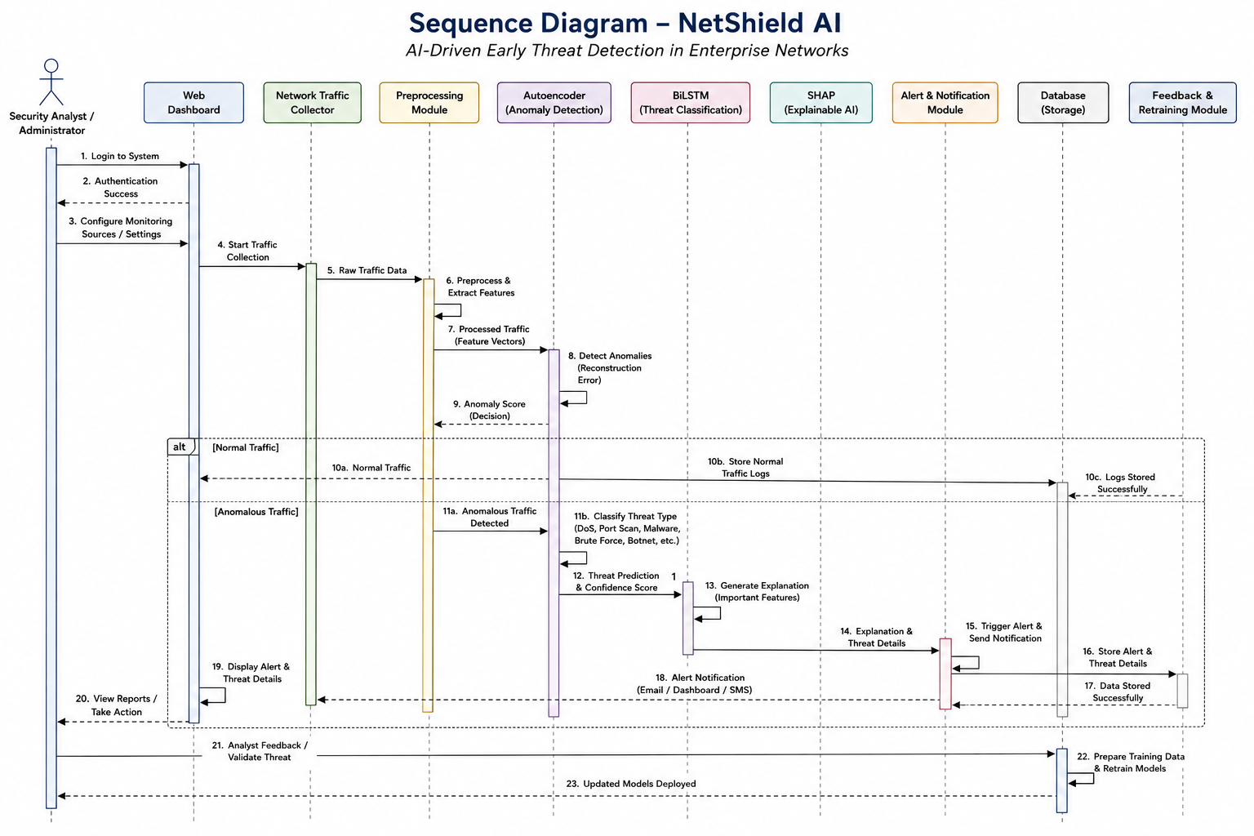
Figure 5 Sequence Diagram

Data Flow Diagram

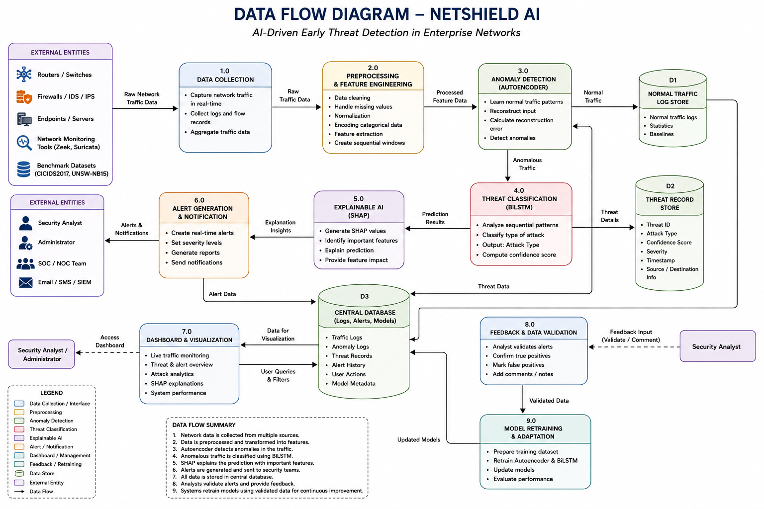
Figure 6 Data Flow Diagram

CHAPTER 5: Implementation

The implementation phase of NetShield AI focuses on developing the proposed AI-driven cybersecurity framework for intelligent early threat detection in enterprise networks. This chapter describes the practical realization of the system architecture, including data collection, preprocessing, feature engineering, anomaly detection, threat classification, explainable AI integration, alert generation, and dynamic model retraining. The implementation combines deep learning models, network traffic analysis techniques, and cybersecurity monitoring components to create an adaptive and scalable threat detection system.
The system is implemented using Python-based AI and data processing frameworks, with benchmark cybersecurity datasets such as CICIDS2017 used for training and evaluation. Network traffic data is processed into structured feature representations, enabling the Autoencoder model to learn normal traffic behavior and the BiLSTM model to classify suspicious activities. SHAP is integrated to provide transparent explanations of model predictions, while alerting and monitoring components simulate real-world cybersecurity operations. The implementation emphasizes modularity, scalability, and adaptability for practical deployment in enterprise network environments.

Programming Language
The implementation of NetShield AI is carried out using a software and hardware environment suitable for developing, training, and evaluating AI-driven cybersecurity models. The project is primarily developed using Python due to its extensive support for machine learning, deep learning, data analysis, and cybersecurity-related libraries.
The core technologies used in the implementation include TensorFlow/Keras or PyTorch for developing the Autoencoder and BiLSTM deep learning models, Scikit-learn for preprocessing, feature scaling, model evaluation, and utility functions, and Pandas and NumPy for data handling, cleaning, transformation, and feature engineering. SHAP (SHapley Additive Explanations) is used to provide explainable AI capabilities by interpreting model predictions and identifying important threat-related features. Visualization and analytics are supported using Matplotlib, Seaborn, and Plotly for dashboards, performance graphs, and monitoring insights.
For backend integration and real-time alert simulation, frameworks such as Flask or FastAPI can be used, while PostgreSQL, MySQL, or MongoDB may be used for secure storage of network logs, alerts, and analytics data. Development tools include Jupyter Notebook, Visual Studio Code, and PyCharm for model development and testing. The system can be implemented on Windows or Ubuntu Linux, with recommended hardware consisting of Intel Core i5/Ryzen 5 or higher, 8–16 GB RAM, SSD storage, and optional NVIDIA GPU acceleration for efficient deep learning model training and faster threat detection performance.

Algorithms Used
The proposed NetShield AI framework uses multiple Artificial Intelligence, Deep Learning, and Explainable AI algorithms to perform anomaly detection, cyber threat classification, and prediction interpretation in enterprise network environments.

5.2.1 Autoencoder Algorithm
The Autoencoder is used for anomaly detection in network traffic. It is an unsupervised deep learning model that learns the normal behavioral patterns of enterprise network traffic by compressing and reconstructing input feature data. During monitoring, traffic that produces high reconstruction error is identified as anomalous or suspicious. This approach helps detect unknown or previously unseen cyber threats effectively.

5.2.2 Bidirectional Long Short-Term Memory (BiLSTM) Algorithm
The BiLSTM model is used for temporal cyber threat classification. Since many cyber attacks occur as sequential patterns over time, BiLSTM analyzes network traffic sequences in both forward and backward directions to capture temporal dependencies. The model classifies suspicious activities into specific cyber threats such as DDoS attacks, brute force attacks, port scanning, malware communication, botnet activity, and data exfiltration attempts.

5.2.3 SHAP (SHapley Additive Explanations)
SHAP is used as an Explainable AI (XAI) technique to provide transparent interpretation of model predictions. It identifies the contribution of individual network traffic features toward a particular threat prediction, helping cybersecurity analysts understand why the system classified specific activities as malicious.

5.2.4 Feature Engineering Techniques
Feature engineering is used to transform raw network traffic data into meaningful behavioral indicators suitable for AI analysis. Important extracted features include packet rate, session duration, bytes transferred, connection frequency, protocol usage, failed login attempts, and flow statistics, which improve the effectiveness of anomaly detection and classification models.

5.2.5 Dynamic Feedback and Model Retraining
A dynamic feedback mechanism is incorporated to continuously improve the performance of the system. Verified alerts and newly observed traffic patterns are added to the training data, allowing periodic retraining of the Autoencoder and BiLSTM models. This enables the framework to adapt to evolving cyber threats and reduce false positives over time.

Proposed Design
The proposed NetShield AI framework follows a modular architecture for intelligent early cyber threat detection in enterprise network environments. The system is designed to monitor network traffic, detect anomalous behavior, classify cyber threats, provide explainable AI insights, and continuously improve through adaptive learning mechanisms.

Modules of the Proposed System

      - Network Traffic Collection Module
This module collects network traffic data from enterprise infrastructure such as routers, firewalls, endpoints, network monitoring tools, or benchmark cybersecurity datasets. It serves as the primary input source for cybersecurity analysis.

      - Preprocessing & Feature Engineering Module
This module cleans raw traffic data, removes inconsistencies, normalizes parameters, and extracts meaningful behavioral features such as packet rate, connection frequency, session duration, protocol usage, bytes transferred, and failed login attempts.

      - Sequence Windowing Module
Since cyber attacks often occur as patterns over time, this module organizes traffic data into sequential time windows, enabling temporal analysis by the BiLSTM model.

      - Anomaly Detection Module
This module uses an Autoencoder-based deep learning model to learn normal network traffic behavior. Incoming traffic that significantly deviates from learned patterns is identified as suspicious based on reconstruction error.

      - Threat Classification Module
Suspicious traffic detected by the anomaly detection layer is forwarded to the BiLSTM model, which analyzes temporal network behavior and classifies cyber threats such as DDoS attacks, brute force attacks, port scanning, malware communication, botnet activity, and data exfiltration attempts.

      - Explainable AI Module
The SHAP-based explainability module interprets model predictions by identifying which traffic features contributed most to a detected threat, improving transparency and trust in the AI system.

7. Alert Generation Module
When malicious activity is detected, this module generates real-time alerts, notifications, and threat reports for cybersecurity analysts through dashboards or integrated communication systems.

8. Database & Storage Module
This module securely stores network logs, anomaly records, classified threat data, alert history, and system analytics for future monitoring, analysis, and reporting.

9. Dynamic Feedback & Retraining Module
This adaptive module collects validated threat detections and analyst feedback to periodically retrain the Autoencoder and BiLSTM models, allowing the system to adapt to evolving cyber attack patterns.

10. Monitoring Dashboard
The dashboard provides live visualization of network activity, detected threats, explainable AI insights, historical logs, and performance analytics, enabling efficient cybersecurity monitoring and decision-making.

Code Implementation (Snippets)
The implementation of NetShield AI includes multiple modules for preprocessing, anomaly detection, cyber threat classification, explainable AI analysis, and alert generation. Representative code snippets of the core implementation are provided below.

5.4.1 Data Preprocessing and Feature Scaling
This module loads the network traffic dataset, performs preprocessing, and normalizes feature values for model training.

import pandas as pd
from sklearn.preprocessing import MinMaxScaler
data = pd.read_csv("cicids2017.csv")
data = data.drop(columns=["Label"])
scaler = MinMaxScaler()
scaled_data = scaler.fit_transform(data)

5.4.2 Autoencoder Model for Anomaly Detection
The Autoencoder learns normal network traffic behavior and detects anomalies using reconstruction error.

from tensorflow.keras.models import Model
from tensorflow.keras.layers import Input, Dense
input_dim = scaled_data.shape[1]
input_layer = Input(shape=(input_dim,))
encoded = Dense(64, activation='relu')(input_layer)
encoded = Dense(32, activation='relu')(encoded)
decoded = Dense(64, activation='relu')(encoded)
decoded = Dense(input_dim, activation='sigmoid')(decoded)
autoencoder = Model(inputs=input_layer, outputs=decoded)
autoencoder.compile(
optimizer='adam',
loss='mse'
)
autoencoder.fit(
scaled_data,
scaled_data,
epochs=20,
batch_size=256
)

5.4.3 BiLSTM Model for Threat Classification
The BiLSTM model analyzes sequential traffic patterns and classifies cyber threats.
from tensorflow.keras.models import Sequential
from tensorflow.keras.layers import Bidirectional, LSTM, Dense
model = Sequential()
model.add(
Bidirectional(
LSTM(64),
input_shape=(30, 20)
)
)
model.add(Dense(32, activation='relu'))
model.add(Dense(6, activation='softmax'))
model.compile(
optimizer='adam',
loss='categorical_crossentropy',
metrics=['accuracy']
)
model.summary()

5.4.4 SHAP Explainable AI
This module explains model predictions by identifying important traffic features.
import shap
explainer = shap.DeepExplainer(model, X_train[:100])
shap_values = explainer.shap_values(X_test[:10])
shap.summary_plot(
shap_values,
X_test[:10]
)

5.4.5 Real-Time Alert Generation
This module generates alerts when malicious activity is detected.
def generate_alert(threat_type, confidence):
if confidence > 0.85:
print(f"Threat Detected: {threat_type}")
print(f"Confidence: {confidence}")
generate_alert("DDoS Attack", 0.92)

These implementation snippets demonstrate the core functional components of the proposed NetShield AI cybersecurity framework.

CHAPTER 6: Testing

Testing is an essential phase in the development of the proposed NetShield AI cybersecurity framework to ensure the correctness, reliability, performance, and effectiveness of the system in detecting cyber threats. The testing process validates the proper functioning of all modules, including network traffic preprocessing, anomaly detection, threat classification, explainable AI interpretation, alert generation, and adaptive feedback mechanisms. Various testing techniques are applied to evaluate detection accuracy, real-time responsiveness, scalability, and system reliability under different cybersecurity scenarios.

Testing Objectives
• To verify the proper functioning of all system modules involved in cyber threat detection and monitoring.
• To ensure accurate anomaly detection and classification of cyber threats in enterprise network traffic.
• To validate real-time alert generation and cybersecurity monitoring capabilities.
• To evaluate the performance, reliability, and scalability of the system under varying traffic conditions.
• To ensure effective explainability and transparency of AI-based threat predictions.

• To verify the adaptive retraining capability of the dynamic feedback mechanism.

Testing Phases

Unit Testing
Each module such as data preprocessing, feature engineering, anomaly detection, threat classification, SHAP explainability, and alert generation is tested individually to verify correct functionality.

6.2.2 Integration Testing
Integration testing is performed to ensure smooth interaction between modules such as anomaly detection, threat classification, explainability analysis, alert generation, and feedback retraining.

6.2.3 System Testing
The complete NetShield AI framework is tested as an integrated cybersecurity monitoring system using benchmark network traffic datasets and simulated threat scenarios.

6.2.4 Performance Testing
Performance testing evaluates processing speed, detection latency, model response time, and real-time monitoring capability under different traffic loads.

6.2.5 Accuracy Testing
The AI models are evaluated for detection accuracy, false positive rate, false negative rate, precision, recall, and F1-score in identifying cyber threats.

6.2.6 User Interface Testing
The monitoring dashboard and alert visualization interface are tested for usability, responsiveness, data presentation, and threat monitoring effectiveness.

Test Cases
Test Case ID | Test Description | Expected Result | Status
TC01 | Load and preprocess network traffic dataset | Dataset should be cleaned and processed successfully | Passed
TC02 | Extract traffic behavioral features | Relevant features should be generated correctly | Passed
TC03 | Detect anomalous traffic using Autoencoder | Suspicious traffic should be identified accurately | Passed
TC04 | Classify cyber threats using BiLSTM | Threat categories should be predicted correctly | Passed
TC05 | Generate SHAP explanations | Feature importance should be displayed clearly | Passed
TC06 | Trigger real-time threat alerts | Alerts should appear instantly | Passed
TC07 | Store logs and threat records | Data should be saved securely in the database | Passed
TC08 | Dynamic feedback retraining | Models should update with validated data. | Passed
TC09 | Dashboard monitoring and analytics | Visualization should display correctly | Passed

Performance Evaluation

The proposed NetShield AI framework demonstrates efficient performance in cyber threat detection and monitoring. The Autoencoder effectively identifies anomalous traffic patterns, while the BiLSTM model accurately classifies different cyber threats using temporal behavior analysis. SHAP provides transparent interpretation of predictions, improving trust and explainability. The alerting system generates rapid threat notifications with minimal delay, while the dynamic feedback mechanism supports continuous improvement of detection performance. The overall framework is designed to provide scalable, adaptive, and intelligent cybersecurity monitoring for enterprise environments.

Testing Tools Used

Python 3.10

TensorFlow / Keras / PyTorch

Scikit-learn

Pandas / NumPy

SHAP

Matplotlib / Seaborn / Plotly

Jupyter Notebook

VS Code / PyCharm

PostgreSQL / MongoDB

FastAPI / Flask

Postman

Wireshark / Zeek / Suricata (for simulated traffic monitoring)

CHAPTER 7: Experimental Results
  - Home Page
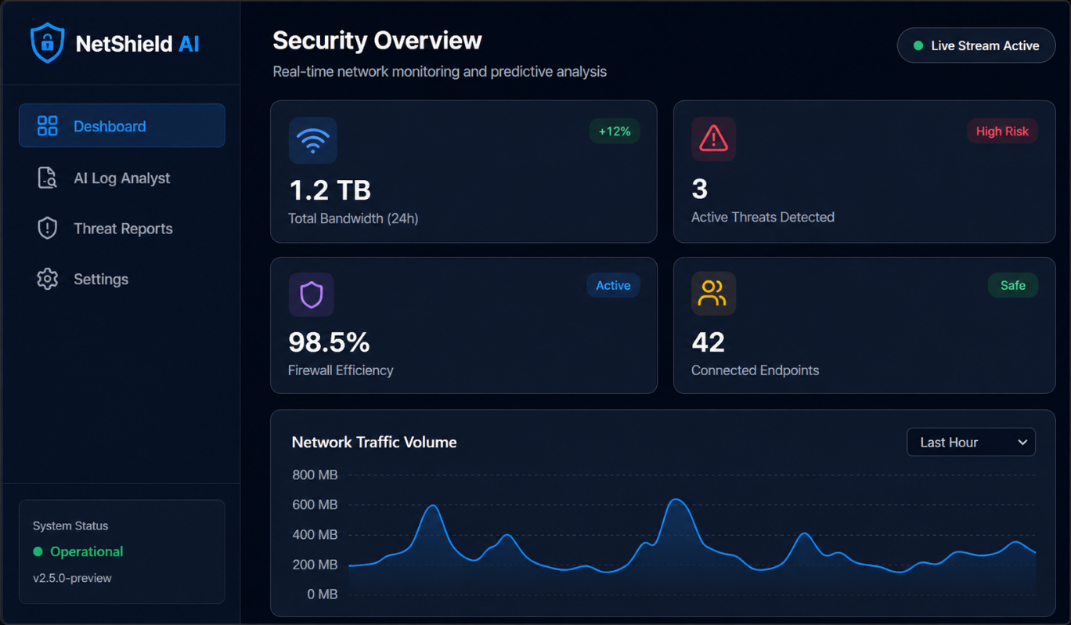
Figure 7 Home Page

  - Home Page
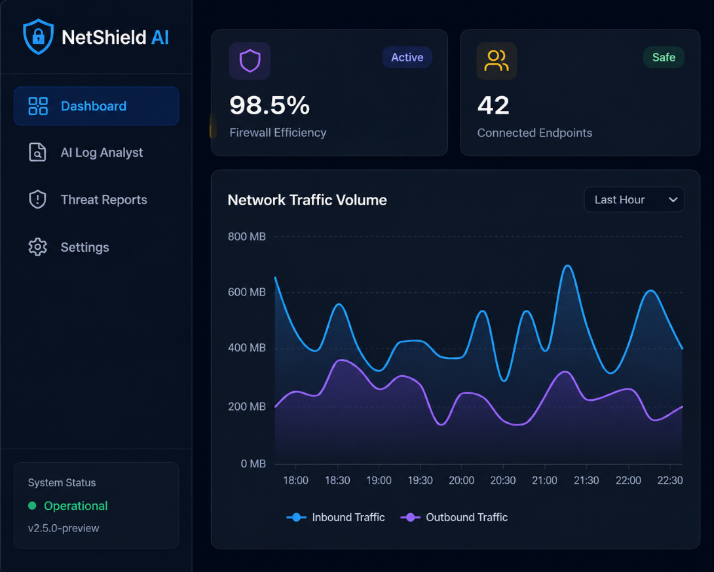
Figure 8 Home Page

  - Logs Page

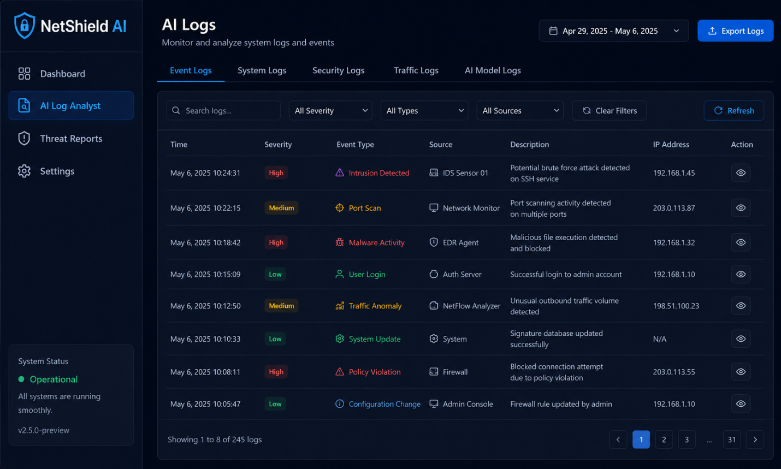
Figure 9 Logs Page
  - Alerts Page

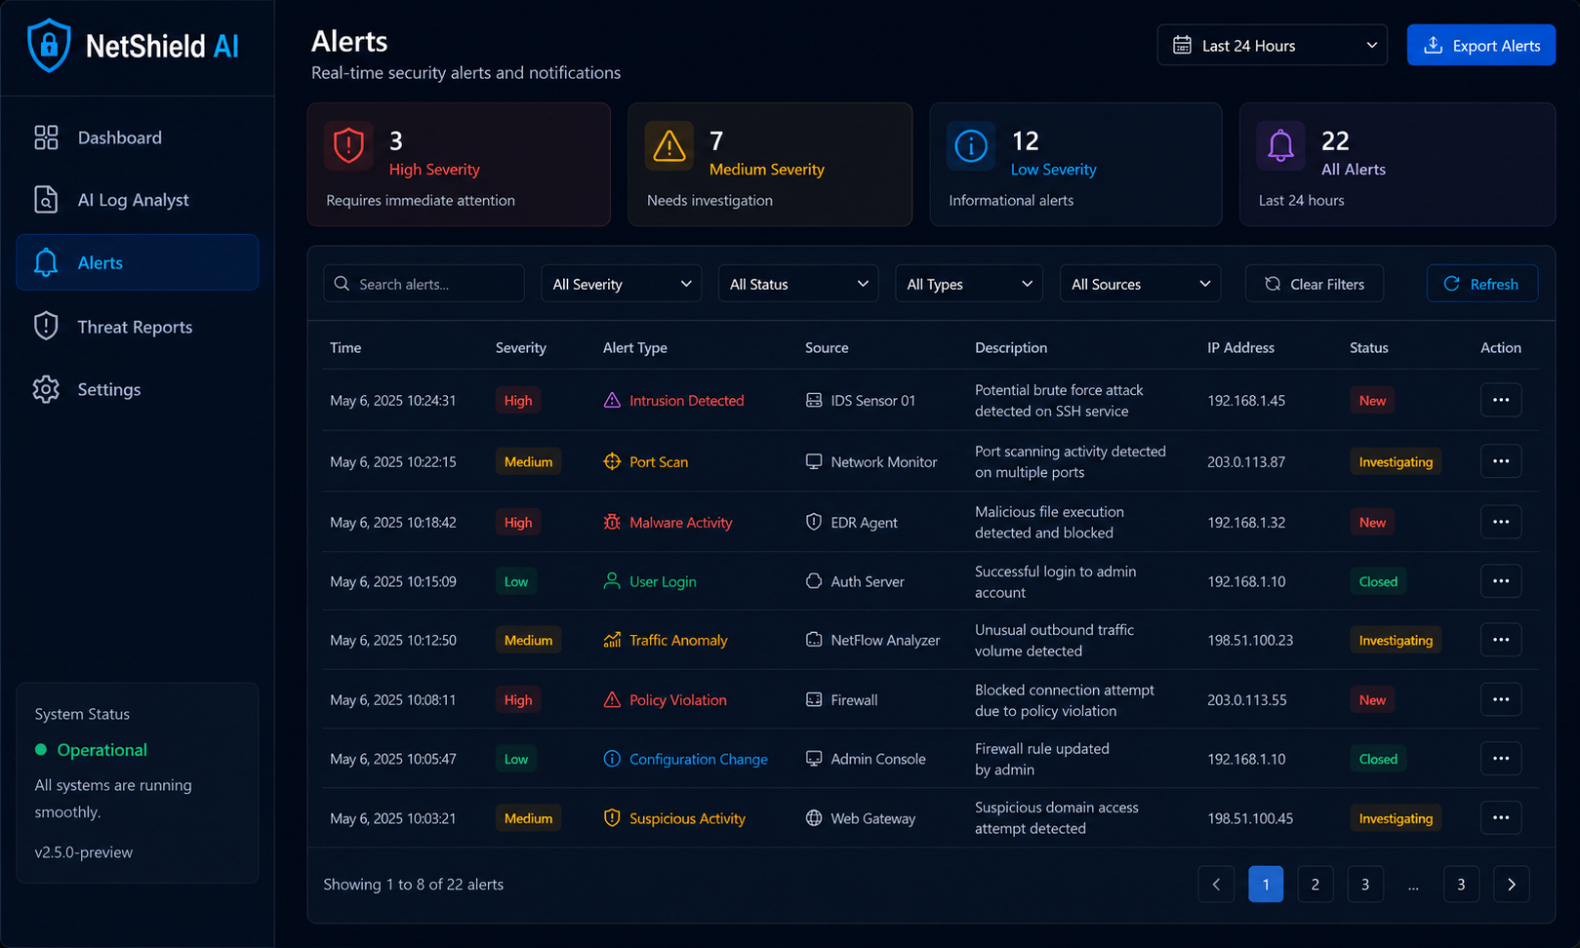
Figure 10 Alerts Page
  - User Management

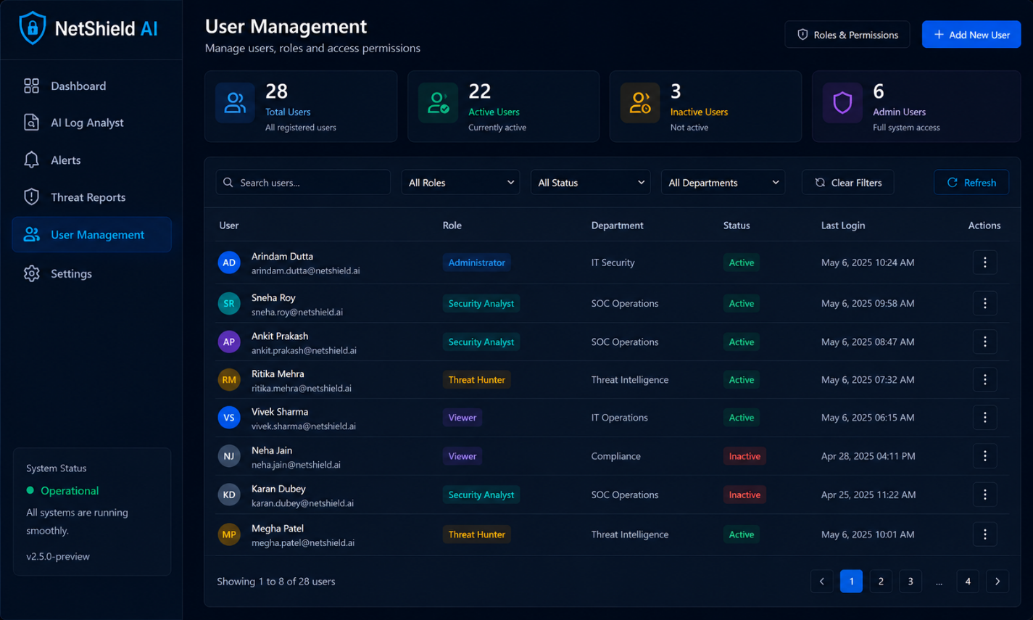
Fig 11 User Management Page
  - Settings

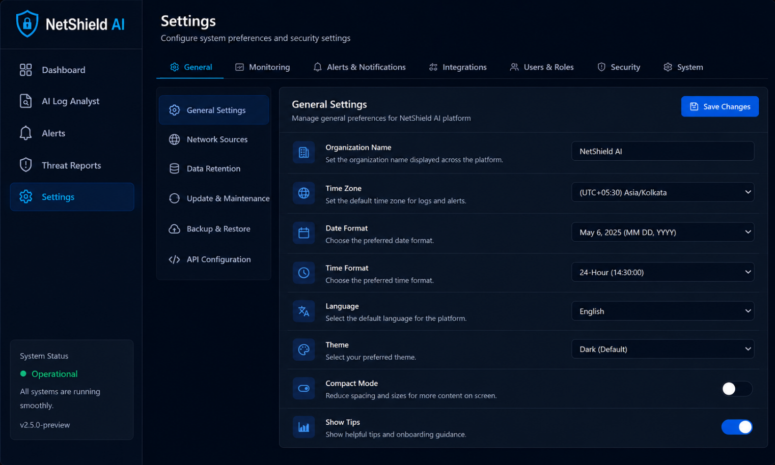
Figure 12 Settings Page

CHAPTER 8: Conclusion

The proposed project, NetShield AI – AI-Driven Early Threat Detection in Enterprise Networks, successfully demonstrates an intelligent cybersecurity framework for detecting and classifying cyber threats in enterprise network environments. The system integrates advanced Artificial Intelligence, Deep Learning, and Explainable AI techniques to analyze network traffic behavior, identify anomalous activities, and classify malicious threats efficiently. By combining Autoencoder-based anomaly detection, BiLSTM-based temporal threat classification, and SHAP-based explainability, the framework provides a proactive and transparent approach to cybersecurity monitoring.
The proposed solution effectively detects cyber threats such as DDoS attacks, brute force intrusions, port scanning, malware communication, botnet activity, and data exfiltration attempts while generating real-time alerts and monitoring analytics. The integration of a dynamic feedback loop enables continuous model retraining and adaptation to evolving cyber threats, improving long-term detection performance and reducing false positives.
Overall, the project demonstrates the effectiveness of AI-driven cybersecurity systems in enhancing enterprise network protection, improving threat visibility, and supporting proactive security decision-making. The proposed framework contributes toward building intelligent, adaptive, and scalable cybersecurity infrastructure for modern digital environments.

CHAPTER 9: Future Enhancements

The proposed NetShield AI framework can be further enhanced by integrating advanced cybersecurity intelligence, scalable deployment architectures, and automated response mechanisms for stronger enterprise protection. Future improvements can focus on improving detection accuracy, real-time scalability, and autonomous threat response capabilities.

- Integration of advanced Transformer-based architectures for improved cyber threat detection and sequence analysis.
- Support for real-time deployment using live network traffic monitoring tools such as Zeek, Suricata, or NetFlow exporters.
- Implementation of automated incident response mechanisms for threat containment, IP blocking, and firewall rule updates.
- Integration with SIEM platforms and enterprise SOC environments for centralized security monitoring and incident management.
- Deployment as a cloud-native cybersecurity monitoring platform for scalable enterprise and multi-tenant environments.
- Enhancement of Explainable AI capabilities with advanced visualization and analyst decision-support tools.
- Integration of federated learning for privacy-preserving collaborative cybersecurity model training across organizations.
- Development of lightweight edge-deployable versions for distributed network monitoring in branch offices or IoT environments.
- Addition of threat intelligence feeds for contextual cyber threat enrichment and smarter detection.
- Implementation of predictive cyber risk analytics for forecasting potential threats before active attacks occur.

References

[1] V. Prajapati, “Advanced Cybersecurity Frameworks: AI for Threat Detection,” IEEE Access, vol. 13, pp. 11234–11248, 2025.
[2] P. Bavadiya and S. Gupta, “AI-driven Data Analytics for Anomaly Detection in Cybersecurity Systems,” IEEE Transactions on Network and Service Management, vol. 22, no. 3, pp. 1456–1471, 2025.
[3] A. R. Alkharabsheh, A. B. Alrashdi, et al., “AI-Driven Proactive Framework for Threat Prediction using Explainable Machine Learning,” IEEE Access, vol. 13, pp. 55421–55439, 2025.
[4] K. Parveen, N. O. Altalhi, and N. Malik, “Building a Secure Future: Artificial Intelligence and Digital Transformation in Cybersecurity,” Journal of Cybersecurity and Digital Transformation, vol. 8, no. 2, pp. 87–101, 2025.
[5] R. C. Rekha and Usha J., “Zero-Trust Security in Intrusion Detection using XGBoost-Based Threat Detection,” Engineering Applications of Artificial Intelligence, vol. 132, pp. 108345, 2025.
[6] P. Kumar, C. R., and N. Sharma, “AI-Based Methods to Detect Threats in Cloud Environments,” International Journal of Information Security, vol. 24, no. 1, pp. 51–68, 2024.
[7] P. Kumar, C. R., and N. Sharma, “Advanced Scalable AI for Extensive Cybersecurity Networks,” Future Generation Computer Systems, vol. 162, pp. 220–238, 2025.
[8] B. Fetaji and M. Fetaji, “FRAUD-X: AI, Blockchain and Cybersecurity Early Warning Framework,” IEEE Access, vol. 13, pp. 66214–66231, 2025.
[9] P. Simha, S. D., and D. Kumar, “Multi-Modal AI for Smart City Threat Detection,” Smart Cities Journal, vol. 6, no. 4, pp. 455–472, 2025.
[10] R. Sathiaseelan, “Prevention of AI-driven Ransomware using Behavioral BiLSTM Detection,” Computers & Security, vol. 140, pp. 103821, 2025.
[11] S. M. Parthasarathy, “Identifying Insider Threats using Artificial Intelligence and Behavioral Profiling,” Journal of Insider Threat Research, vol. 11, no. 2, pp. 91–108, 2025.
[12] M. Jaworski and B. Pahlevanzadeh, “Hybrid Intelligence Endpoint Defense for Proactive Cybersecurity Monitoring,” Cyber Defense Review, vol. 9, no. 1, pp. 33–52, 2026.

Program Outcomes (POs)

PO1: Engineering Knowledge: Apply knowledge of mathematics, natural science, computing, engineering fundamentals and an engineering specialization to develop the solution of complex engineering problems.

PO2: Problem Analysis: Identify, formulate, review research literature and analyze complex engineering problems reaching substantiated conclusions with consideration for sustainable development.

PO3: Design/Development of Solutions: Design creative solutions for complex engineering problems and design/develop systems/components/processes to meet identified needs with consideration for the public health and safety, whole-life cost, net zero carbon, culture, society and environment as required.

PO4: Conduct Investigations of Complex Problems: Conduct investigations of complex engineering problems using research-based knowledge including design of experiments, modelling, analysis &amp; interpretation of data to provide valid conclusions.

PO5: Engineering Tool Usage: Create, select and apply appropriate techniques, resources and modern engineering &amp; IT tools, including prediction and modelling recognizing their limitations to solve complex engineering problems.

PO6: The Engineer and The World: Analyze and evaluate societal and environmental aspects while solving complex engineering problems for its impact on sustainability with reference to economy, health, safety, legal framework, culture and environment.
PO7: Ethics: Apply ethical principles and commit to professional ethics, human values, diversity and inclusion; adhere to national &amp; international laws.

PO8: Individual and Collaborative Team work: Function effectively as an individual, and as a member or leader in diverse/multi-disciplinary teams.

PO9: Communication: Communicate effectively and inclusively within the engineering community and society at large, such as being able to comprehend and write effective reports and design documentation, make effective presentations considering cultural, language, and learning differences

PO10: Project Management and Finance: Apply knowledge and understanding of engineering management principles and economic decision-making and apply these to one’s own work, as a member and leader in a team, and to manage projects and in multidisciplinary environments.

PO11: Life-Long Learning: Recognize the need for, and have the preparation and ability for i) Independent and life-long learning ii) adaptability to new and emerging technologies and iii) critical thinking in the broadest context of technological change

